Chapter 2

ARPA net:a network of computers

The way that ARPA net works is the bases of the Internet.(Package Switching)

Internet: a global network system of computer,electronic devices and networks connected to each other that provides resources and services through communication using standardized protocols like TCP/IP.

The difference between Internet and World Wide Web:

1. Internet is an infrastructure.
2. World Wide Web is a multimedia Pages.
3. The world Wide Web is written in HTML.
4. HTTP protocols are used to transfer web pages.
5. Internet use IP protocols.

It’s not Wide Area Network.

Packet switch(Connectionless mode of the communication):

Circuit switch(Need the connection between the sender and the receiver):Busy

Does not allow other data packets to be transmitted during a connection session.

In the case of circuit failure, the communication fails

NIC(Network Interface Card):

Bluetooth (Wireless)

Wi-Fi (Wireless)(802.11 protocols)(2.4GHz)(100Mbps)

Ethernet(Wire)

USB(Wire)

Data packets:A file sent over a network is broken into small chunks of data known as

data packets.

Protocols: The rules for communication.

Switch(Unicast,Broadcast,Multicast): hardware used to connect together a number of devices to form a LAN that directs incoming data packets to a specific destination address only.

Switches filter data packets.

Switches store the MAC address of the devices.

Hub(Broadcast):hardware used to connect together a number of devices to form a LAN that directs incoming data packets to all devices on the network.

DHCP server: provide IP address automatically

(W.)N.I.C:(Wireless) Network Interface Card

(W.)A.P:(Wireless) Access point

(wireless) access point which allows a device to access a LAN without a wired connection.

Bridge:device that connects LANs

UTP: Unshielded Twisted Pair

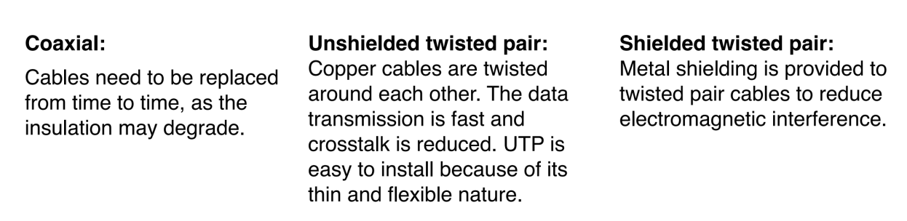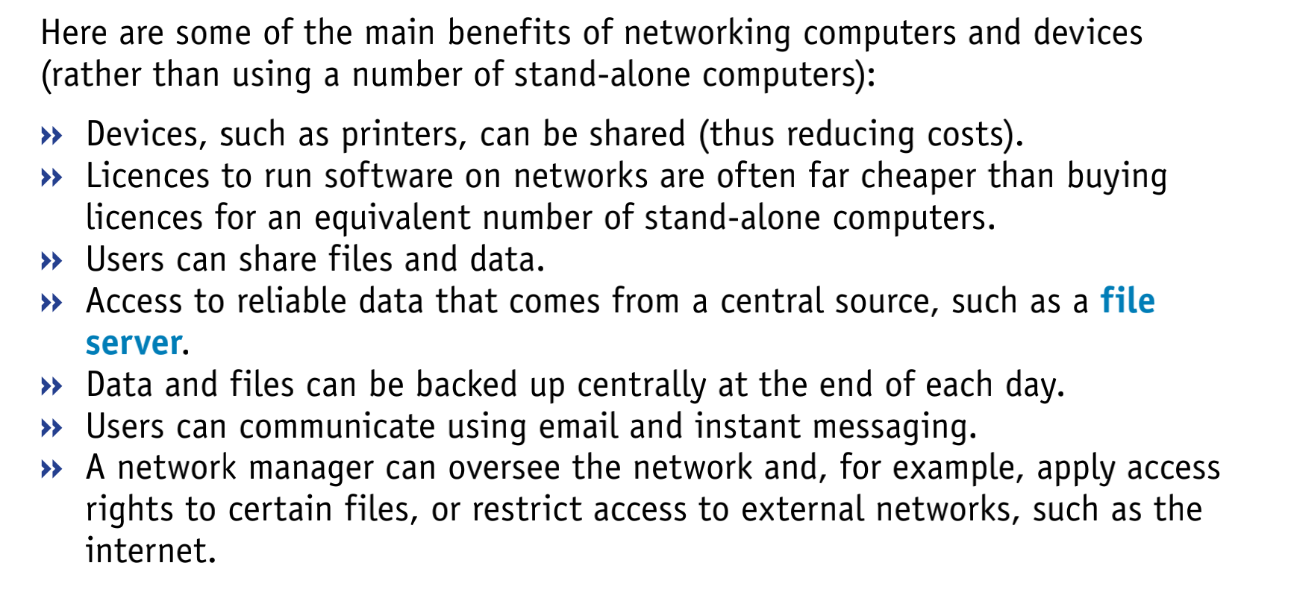

Router: A router forwards data packets between computer networks until it reaches its destination.

device which decides about the path in which the data packets has to be sent and communicates networks using same protocol.

A router decides about the path in which the data packet has to be sent.

Gateway: The hardware translated data packet that transverses across networks that use different protocols and decided the ip is in side the network or not.

Both gateway and router use IP and MAC addresses.

Modem: The devices that turns digital data only for communication into electrical signal.

MAC:Media Access Control

LAN:Local Area Network(Building 100-1km)a network of computers

within the same building.

N.A.T:(Network Address):Translation translate between public IP addresses and local IP addresses.

WAN:Wide Area Network(Continent 100km thousands)a network of LANs in different geographical places, that is, connecting different cities in the world.

MAN:Metropolitan Area Network(City1km-100km)

SAN:Storage

Wired connection:A wired network uses copper cables or fibre-optic cables to connect the components of a computer.

Wireless connection: A wireless network uses radio signals to connect computers within its range.

Topology

Topology:The arrangement of the various devices in a network is called its topology.

Physical Topology

|  |  |  |  |  |  |
| --- | --- | --- | --- | --- | --- |
| Type of topology | Bus | Ring | Star | Full Mesh | Partial Mesh |
| Advantages | easy and inexpensive to install |  | If a cable fails,only the device connected through it is affected.  Data collisions aren’t incremented with more devices. | If a cable fails, the |  |
| Description | Use terminater | In a ring network,the computers and devices are connected in a closed loop configuration.And each device is conneced directly to its adjacent devices. |  |  |  |
| disadvantages | If the main cable fails , the whole network fails | If one of the cable or one of the devices fails, the whole network fails | Expensive to install  If central device fails,the whole network fails | Expensive and hard to install. |  |

When two messages using the same data channel could be sent at same time, it leads to a collision.

Mesh is the best for Internet.

Networking Models

|  |  |  |
| --- | --- | --- |
|  | Peer-to-Peer-Network | Client-to-server network |
| Type |  | Web servers,Application,  Network Attached Storage,Print servers,Mail servers |
| descriptions | Share the resources equally.The **peer-to-peer** model does not have a central server. Each of the nodes  (workstations) on the network can share its files with all the other nodes, and  each of the nodes will have its own data. |  |
|  |  |  |
|  |  |  |
|  |  |  |

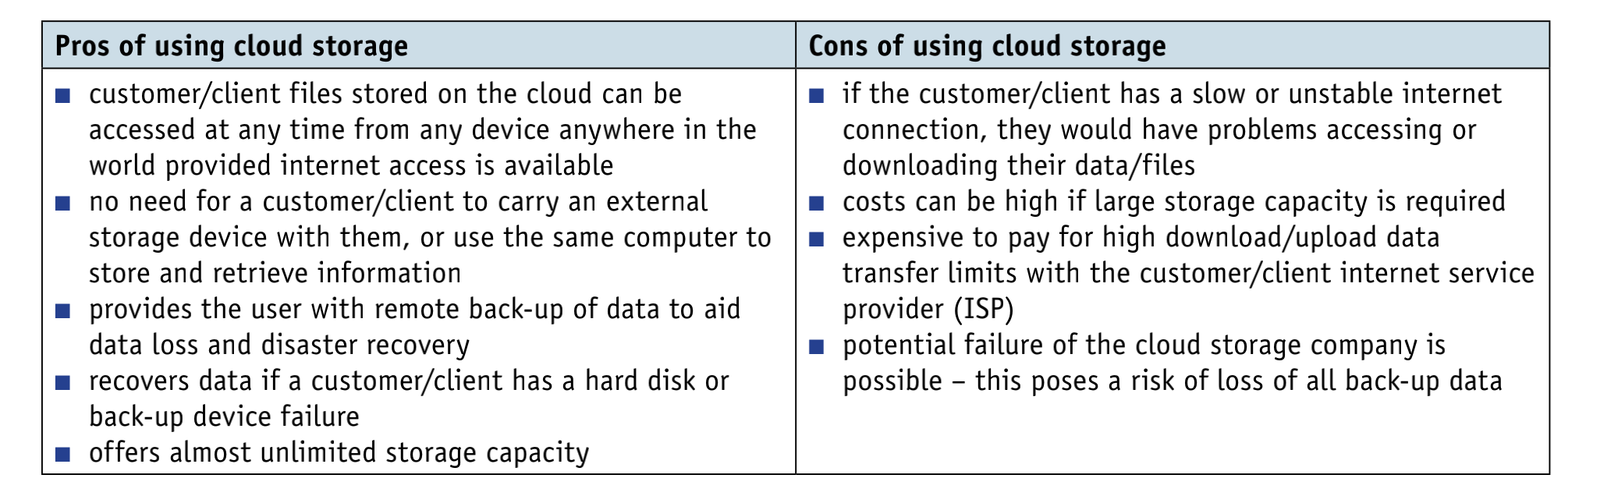

|  |  |  |  |
| --- | --- | --- | --- |
|  | Thin Client | Thick Client | Cloud computing |
| Advantages | Easy and inexpensive to set up | Operates without server connection  Robust and reliable  Used for powerful software application |  |
| Disadvantages |  | Expensive to install as it requires highly specialized computers at the client side |  |
| Description | A thin Client is highly dependent on the server for data processing and storage. |  |  |

|  |  |  |
| --- | --- | --- |
| Application | L4 |  |
| Transport | L3 | TCP |
| Network | L2 | IP protocols  (conflicts) |
| Link | L1 | Ethernet  WiFi |

IP conflict:When there are two or more devices in the same network and have the same local IP,there will be a IP conflict

10.14.10.244

Range: 0 1

255 254

Two ip is for gateway and broadcast.

Host:(2^16)-2

Network:2^16

Network:10.14

Host ID:10.244

LEO(closest,use higher frequency): Better for network communication.

GEO:Larger covering.

URL:protocols://website address/path/filename